**Course: B.Tech. (CSE), Year: II, Semester: IV**

**Software Engineering (BCSC 0009)**

1. “Software Does not wear out but hardware does” explain the statement with the help of Bathtub curve.

Ans:



1. Write any four major disadvantages of waterfall model.

Ans:

* This Model is not suitable to accommodate any type of changes in between the development process.
* Users have little interaction with the project team. Their feedback is not taken during development.
* After the development process starts changes can not be accommodated easily.
* Model do not support delivery of software in pieces.
* This model is just like a one-way street. Once the phase X is completed and the next phase Y has started, then there is no provision of going back.
* Not suitable for new projects because of uncertainty in the specification.
* Customers gets opportunity to review the product very late.

1. What is the purpose of feasibility study? Explain any four parameters that plays an important role in conducting a feasibility study.

Ans. **Purpose:** Feasibility Study is a study to evaluate feasibility of proposed project or system.

it is a measure of the software product in terms of how much beneficial product development will be for the organization in a practical point of view. Feasibility study is carried out based on many purposes to analyze whether software product will be right in terms of development, implantation, contribution of project to the organization etc.

Whether the project can be done.

Whether the final product will benefit its intended users.

**four parameters:**

Technical Feasibility –

Economic Feasibility –

Legal Feasibility –

Schedule Feasibility –

Operational Feasibility –

• Are the project’s cost and schedule assumption realistic?

• Does the business model realistic?

• Is there any market for the product?

Section B

1. The company wants to develop a software but requirements are not clear at initial phase and company is not so mature to adopt agile model. Which is the best development model in your opinion and why? Explain the model with the help of diagram.

Ans. **Prototyping Model:** Prototyping Model is a software development model in which prototype is built, tested, and reworked until an acceptable prototype is achieved. It also creates base to produce the final system or software. It works best in scenarios where the project's requirements are not known in detail.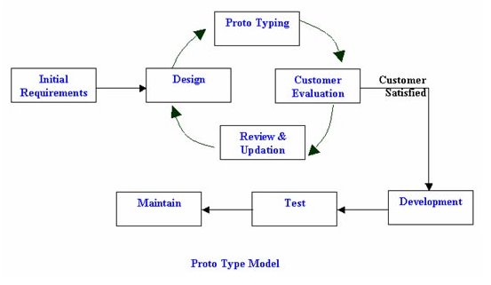

1. What is requirement elicitation? Explain any four methods of requirement elicitation.

Ans: Requirement elicitation is the process of collecting the requirements of a system or requirement gathering from user, customers and stakeholders by conducting meetings, interviews, questionnaires, brainstorming sessions, prototyping etc.

**Four methods:**

Interviews

Brainstorming Sessions

Facilitated Application specification Techniques (FAST)

Quality Function Deployment

The Use Case Approach

1. Create use case diagram for the following requirements:

Customer uses a bank ATM to check balances of his/her bank accounts, deposit funds, withdraw cash and/or transfer funds (use cases). ATM Technician provides maintenance and repairs to the ATM.

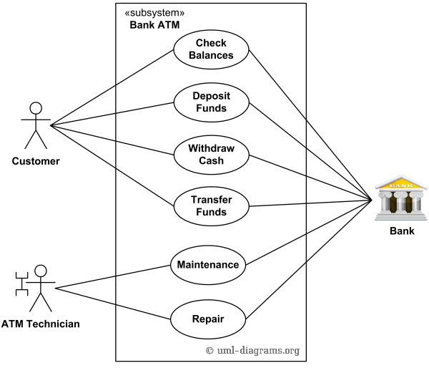

Section C

Q.III Why Design of a software is important? How modularity plays an important role in designing a software? What is Module Coupling? Explain different types of Module Coupling with the help of an example.

Ans: Why Design of a software is important: The software design helps the coder and programmer realize the prototype of the application and development of software codes and implementing them at the user level. The software design allows the movement of attention from the problem towards a solution.

How modularity plays an important role in designing a software: Modularity is the single attribute of software that allows a program to be intellectually manageable. It enhances design clarity, which in turn eases

implementation, debugging, testing, documenting, and maintenance of software product.

Module Coupling: Coupling is the measure of the degree of interdependence between modules

Data coupling: Stamp coupling The dependency between module A and B is said to be data coupled if their dependency is based on the fact they communicate by only passing of data. Other than communicating through data, the two modules are independent.

Stamp coupling occurs between module A and B when complete data structure is passed from one module to another.

Control coupling

Module A and B are said to be control coupled if they communicate by passing of control information. This is usually accomplished by means of flags that are set by one module and reacted upon by the dependent module.

External Coupling:

A module has a dependency to other module, external to software or hardware.

Common coupling

With common coupling, module A and module B have shared data. Global data areas are commonly found in programming languages. Making a change to the common data means tracing back to all the modules which access that data to evaluate the effect of changes.

Content coupling

Content coupling occurs when module A changes data of module B or when control is passed from one module to the middle of another. In Fig. 9, module B branches into D, even though D is supposed to be under the control of C.

Q.IV:

